Case Study: ABC Analysis

Solution

1. Create a dataset

Create a new document in SAP Predictive Analysis

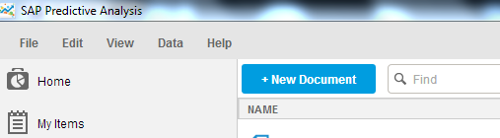

Select SAP HANA as data source

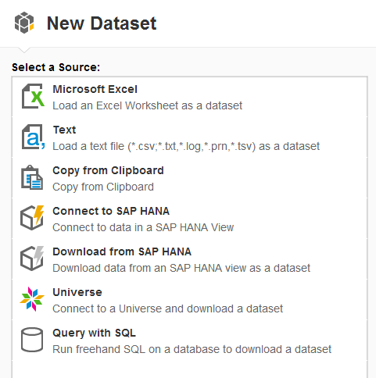

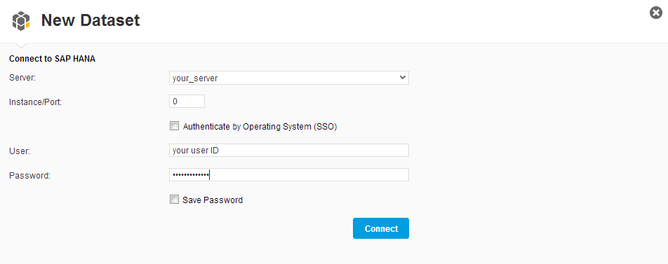

Select the analytic view GBI_DEMO1_ABC_ANALYSIS_AV

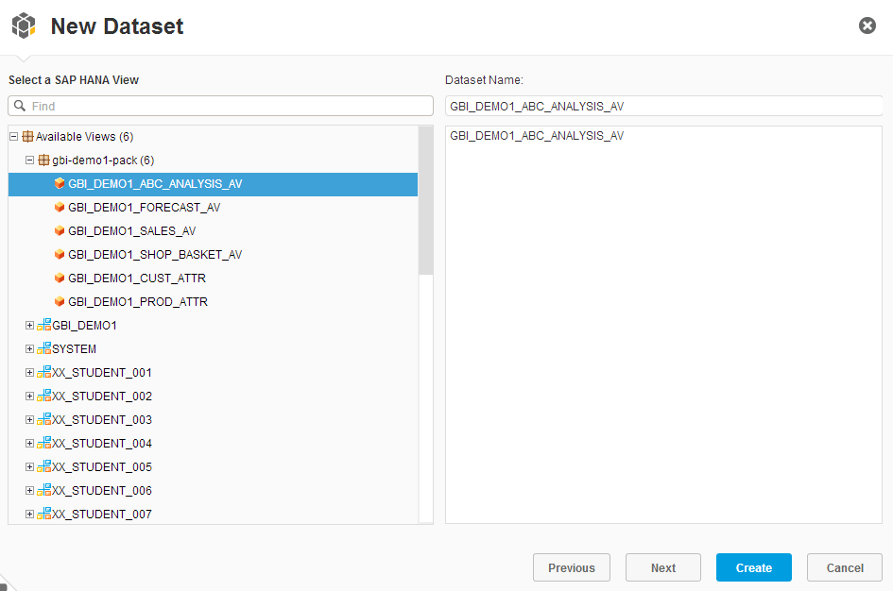

Choose Measures and Dimensions

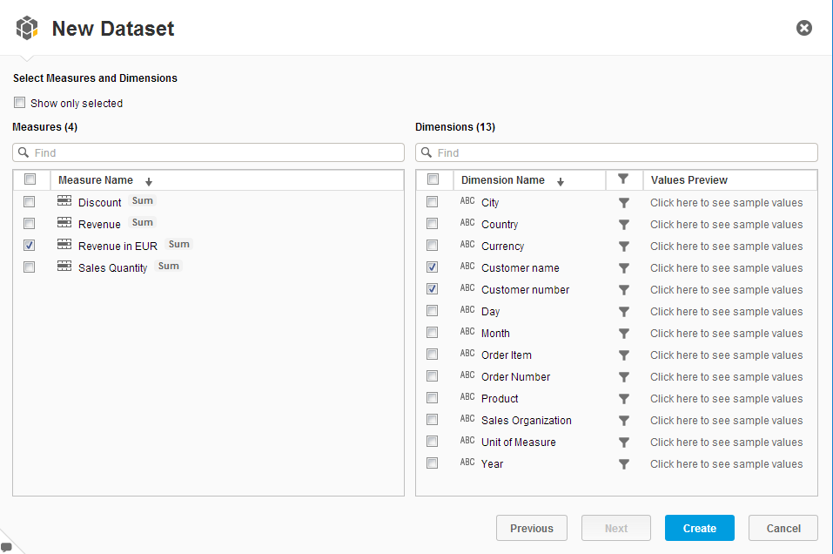

What would happen, if you do not pre-select respective dimensions?

* The ABC analysis would rate transactions (no aggregation on Customer Level)

1. Analyze the data

Navigate to the PREDICT Tab in your document

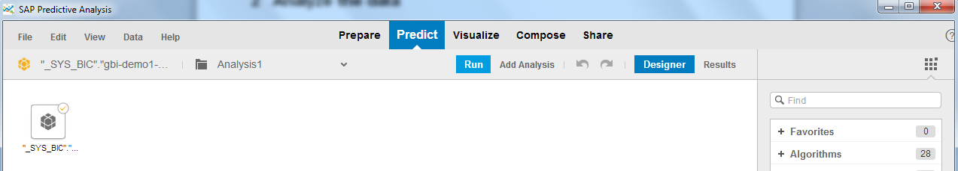

Analyze the data



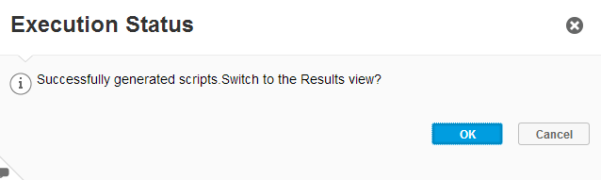

Click on the first icon under *DATA INSIGHT*  and analyze the data. Answer the following questions:

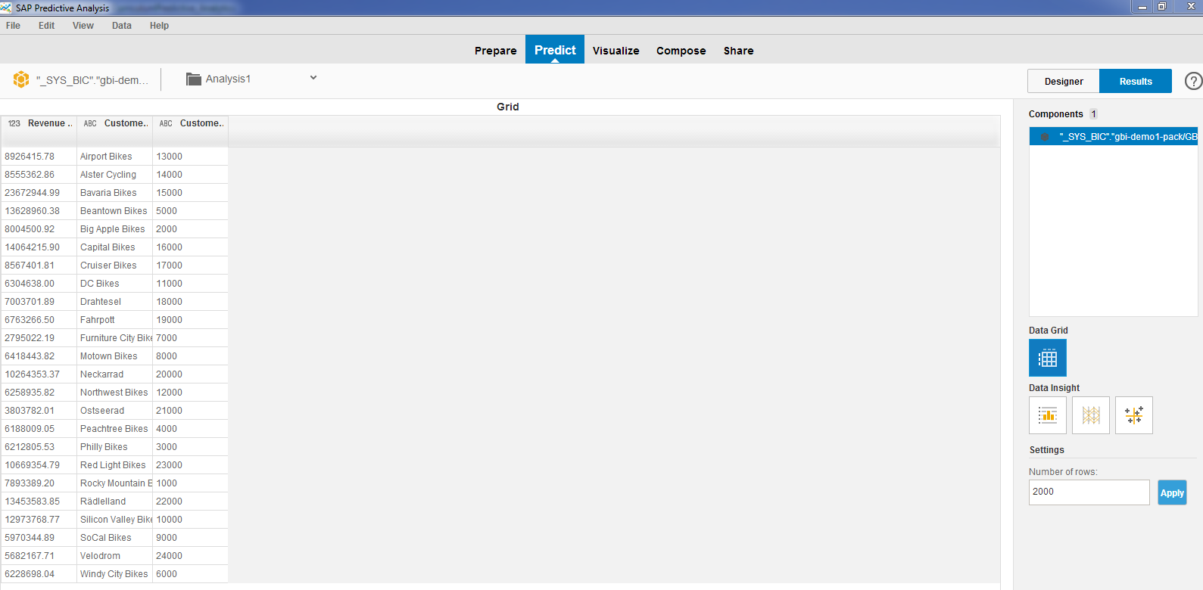

1. How many distinct customers does the wholesaler GBI have?

24

1. What is the average revenue they get from their customers?

About 8.76 mio

1. How many customers with a revenue roundabout 10 million do they have?

6

1. Apply the algorithm

Navigate to the DESIGNER in the PREDICT tab in your document

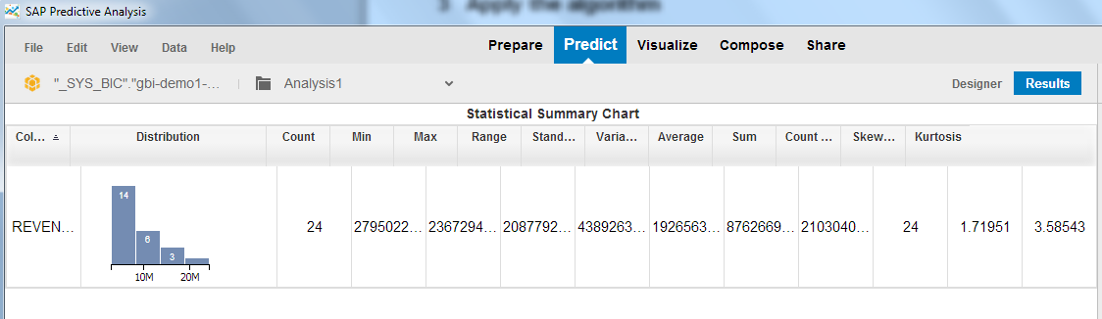

Add and configure the ABC algorithm

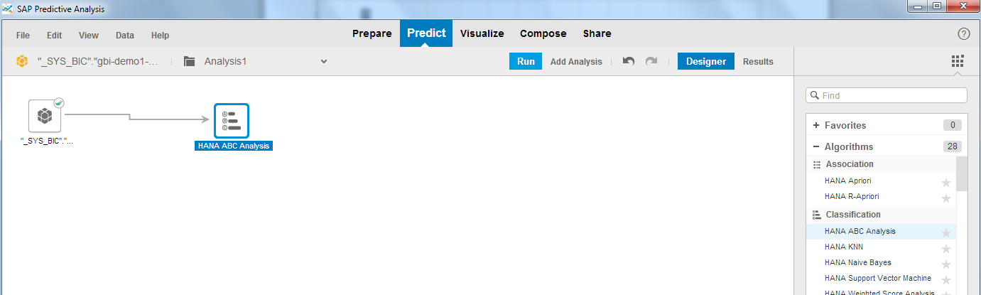Double click on the HANA ABC Algorithm icon on the workspace to configure the algorithm.

Configure following settings on the properties tab:

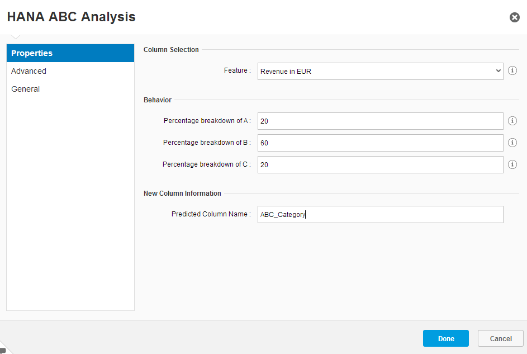

Add a HANA writer to your analysis

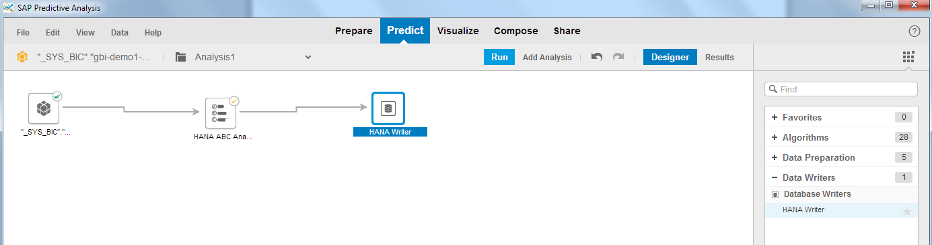

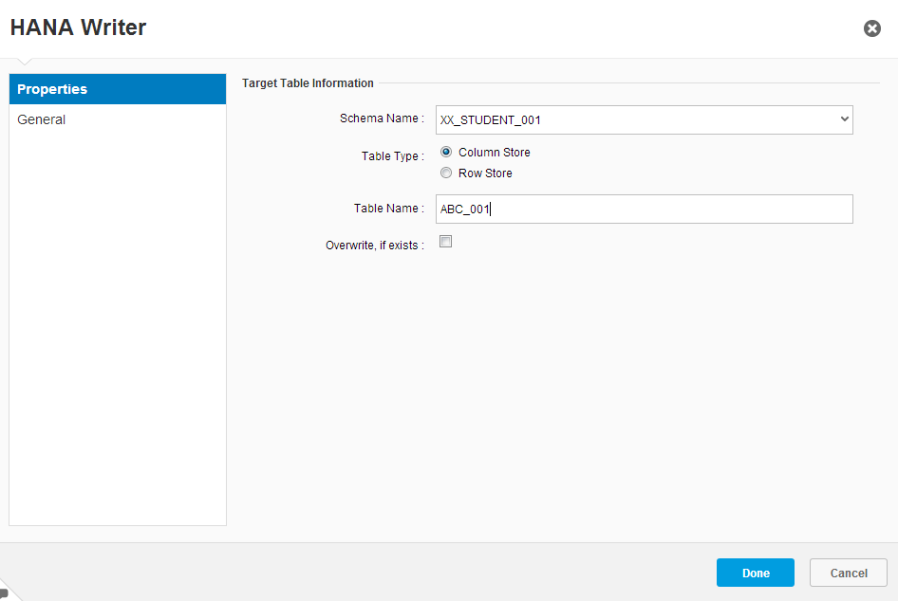

Run the analysis

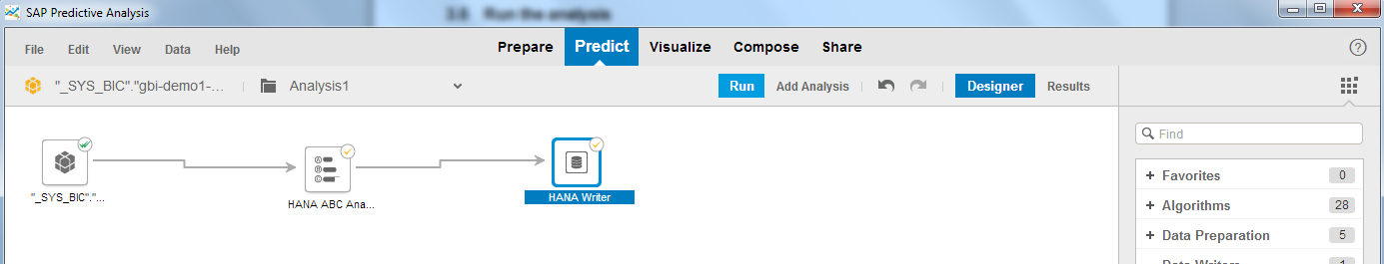

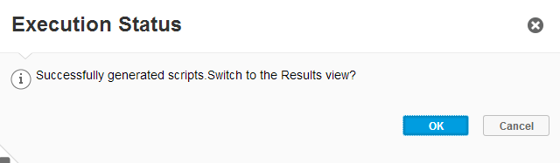

1. Analyze the results

Check and interpret the data

1. Who are your best three customers?

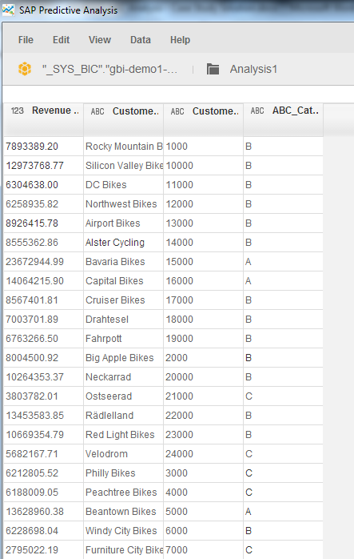

1. What is the revenue of the company “Bavaria Bikes”?



Save the document

*File 🡪 Save as* or by clicking on *Crtl + Shift + s.*

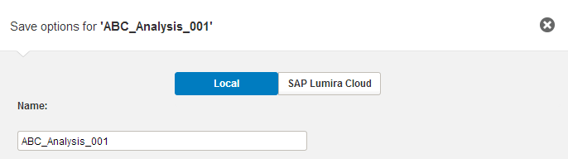

1. Visualize your results

Create a new document in SAP Predictive Analysis

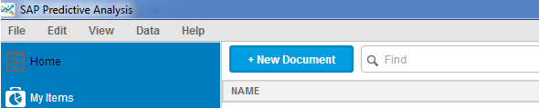

Select SAP HANA as data source

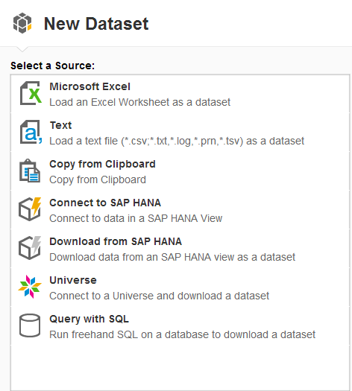



Select the table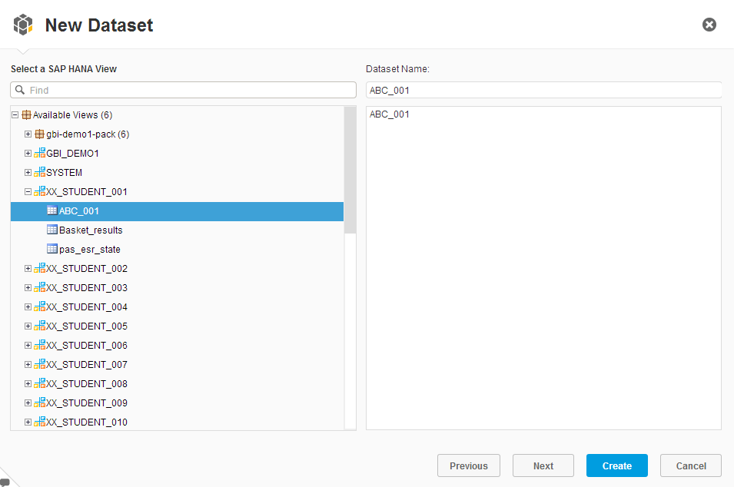

Choose the VISUALIZE Tab



Create a Measure

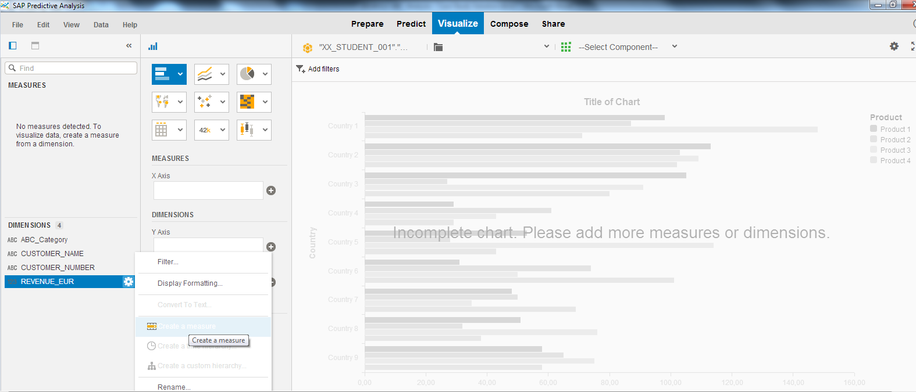

Change the Measure type

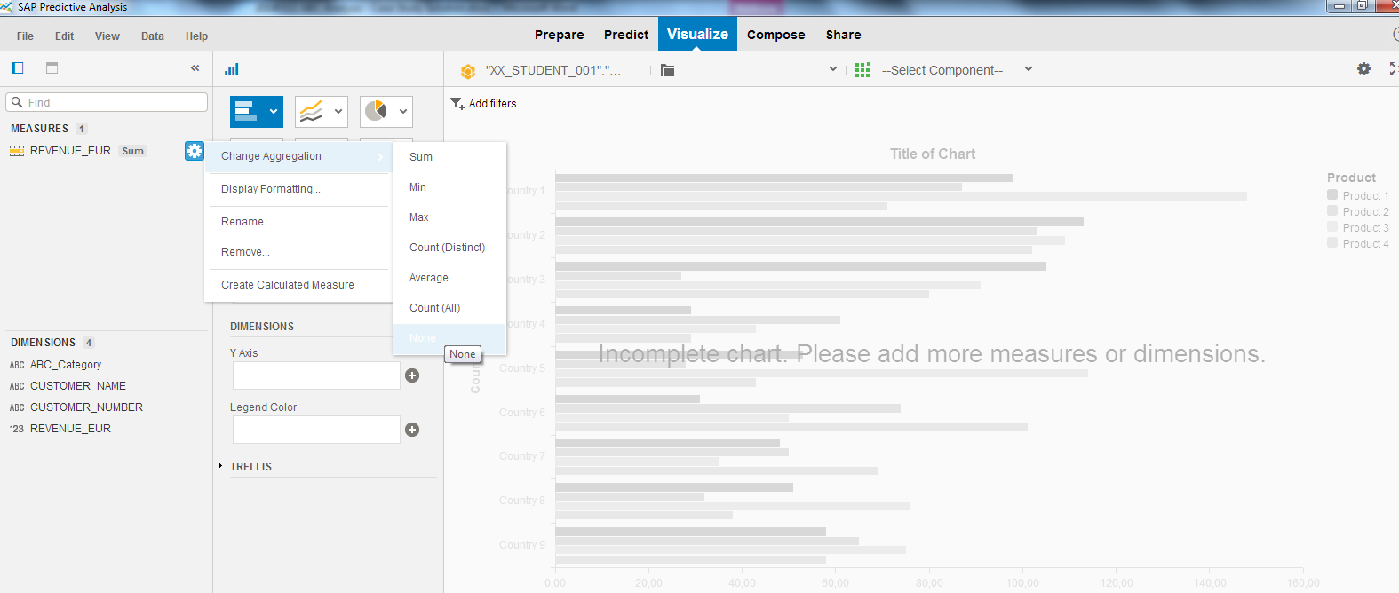

Create a visualization

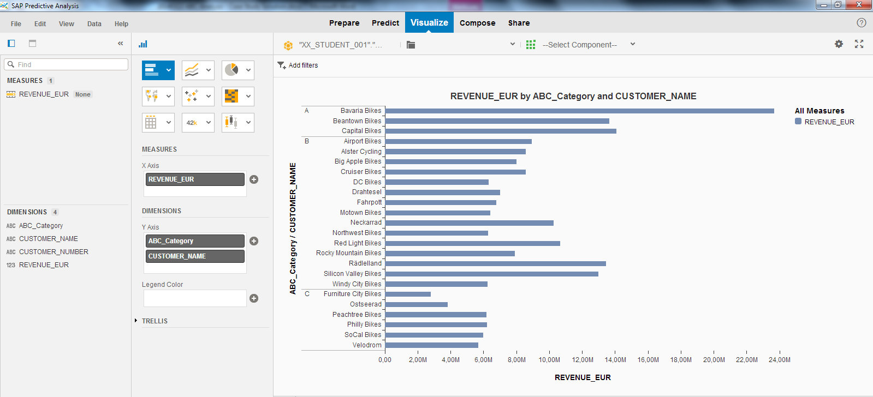

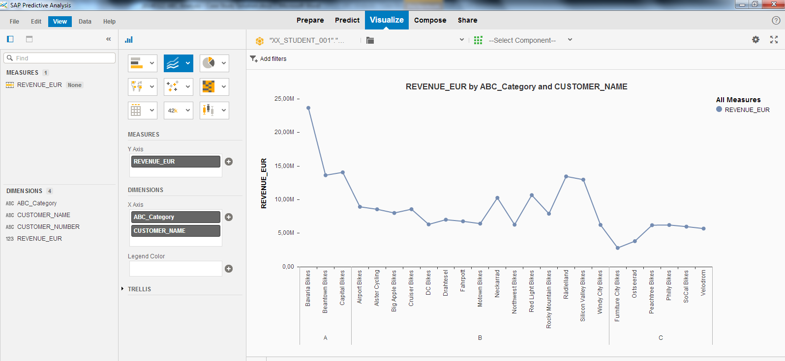

1. Create a presentation for the Chief Marketing Officer

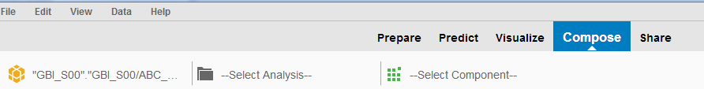Change to COMPOSE

Select a blank board as page type

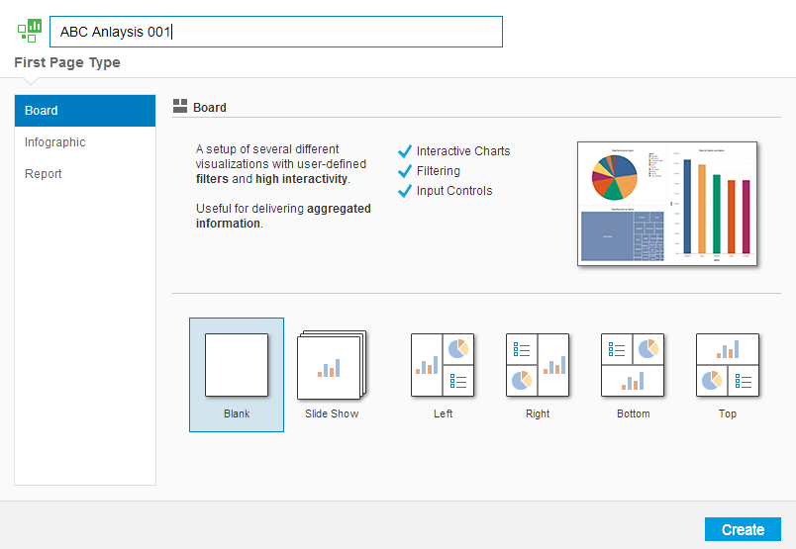

Add the previously created visualization

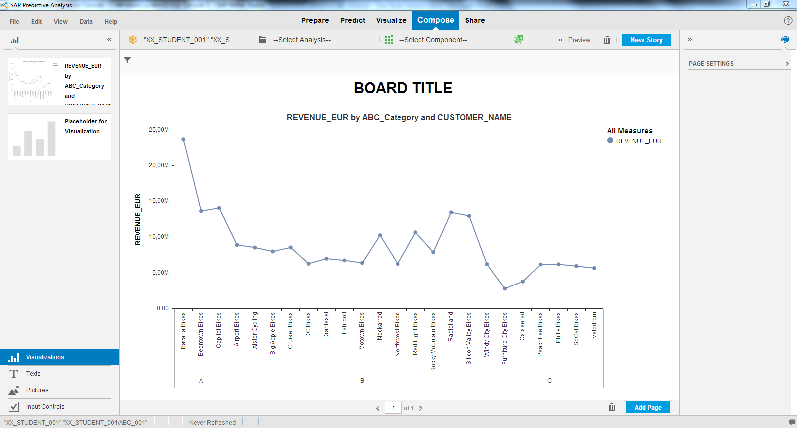

Add a simple text field to the presentation

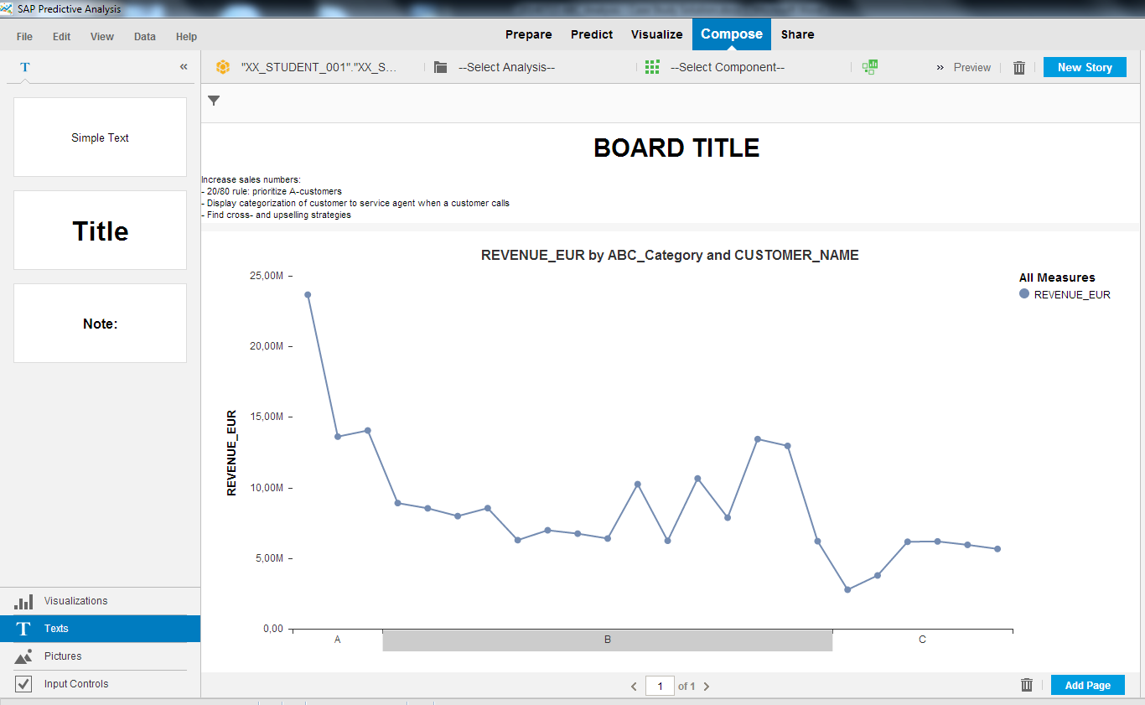

Change the board title

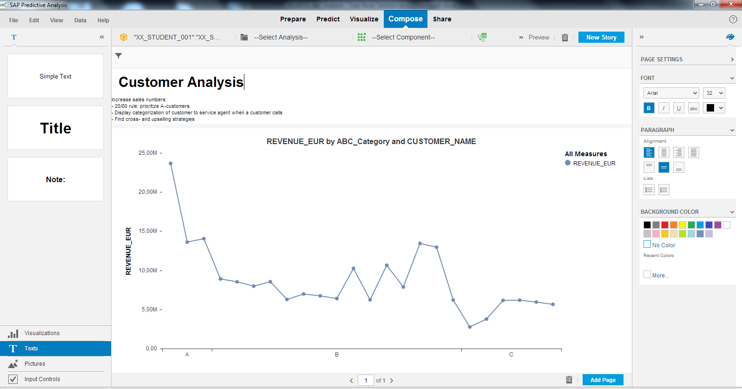

Preview the presentation slide

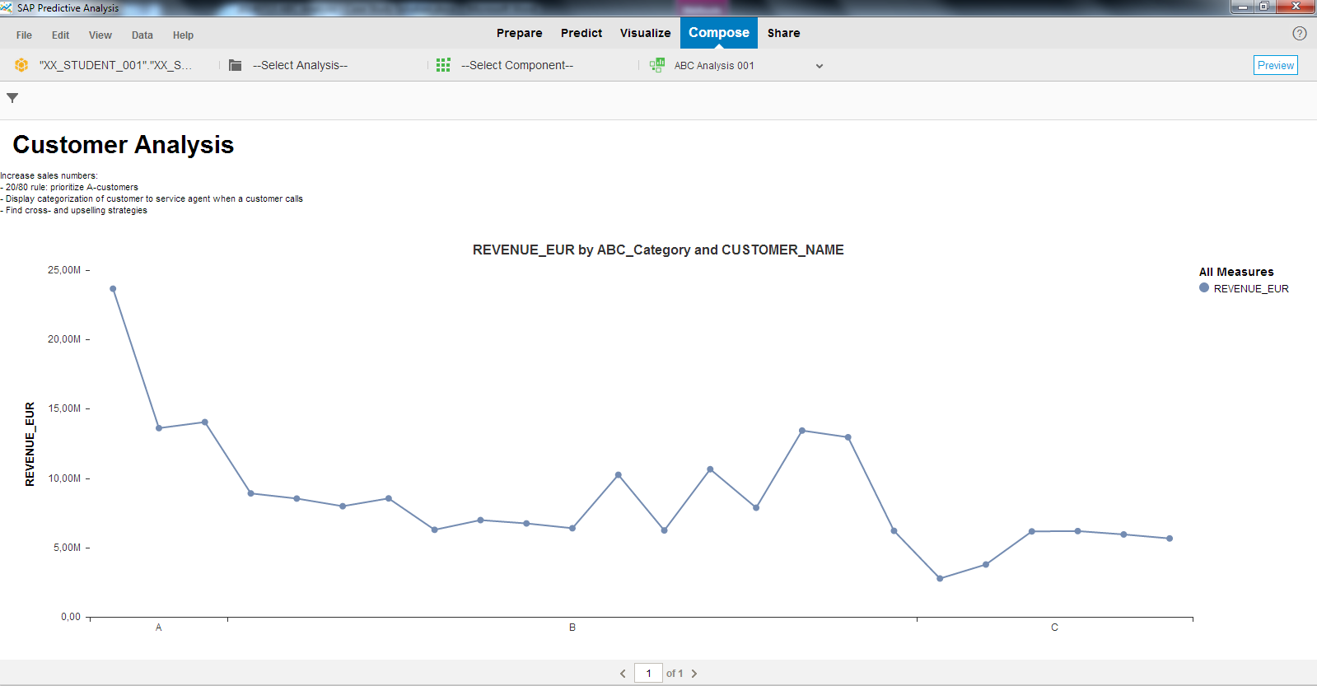

Save your presentation

